

SIMATS ENGINEERING

Saveetha Institute of Medical and Technical Sciences Chennai- 602105

Student Name: K ARAVIND KUMAR REDDY Reg. No.: 192324225
Course Code: 4303 Slot: C
Course Name: INTERNET PROGRAMMING
Course Faculty: Dr. N. Marie Claude

Project Title: Design and Development of an Intelligent Personal Finance Management System with AI-Driven Expense Analytics and Budget Optimization
Module 2 - Authentication & User Management
Module Photographs: (3 photographs –Module Photo, Individual student contribution module work in the project and presentation image)
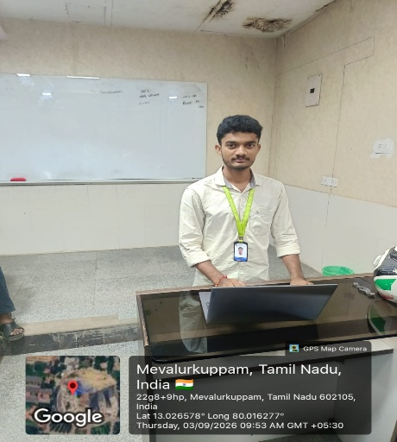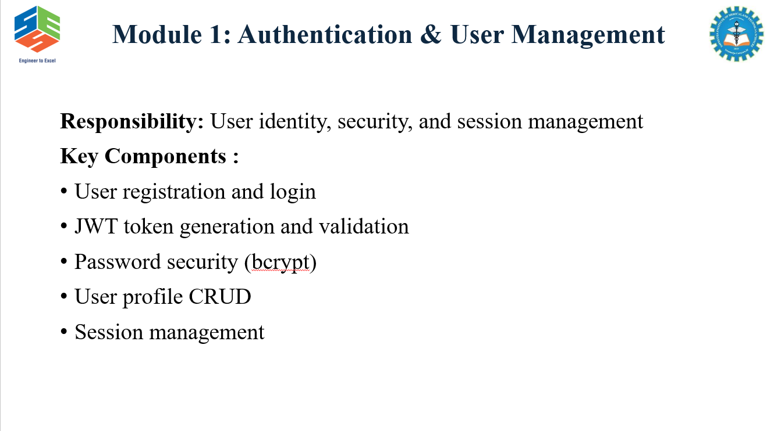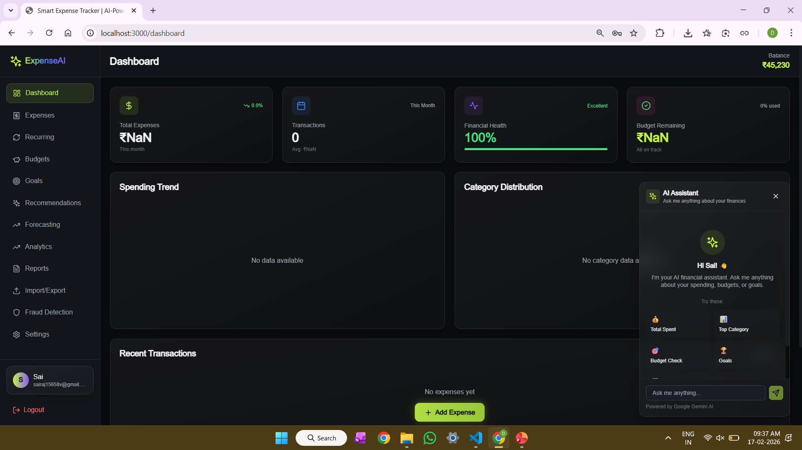
Project Description: (here you write what you did in this project (contribution) including Model
Description
The Authentication & User Management module provides a secure and personalized platform for managing user access to the Intelligent Personal Finance Management System. It allows users to register, log in, and manage their profiles using secure authentication mechanisms. The system verifies user credentials and provides authorization-based access to financial features such as income tracking, expense management, budget planning, and financial analytics. It also manages user sessions, logout functionality, account settings, and personalized financial records. Each user’s financial data is securely associated with their individual account to maintain privacy, confidentiality, and data security. This module serves as the foundation of the system by ensuring that financial information is accessible only to authorized users while providing a personalized experience.

Student Signature Guide Signature

